DATE: 17.08.2018
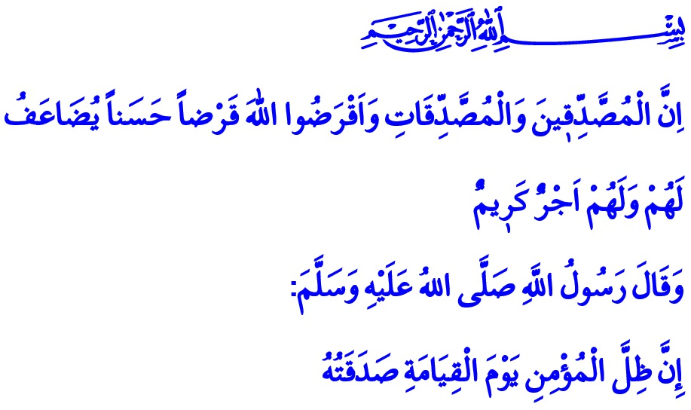
CEASELESS CHARITY (SADAQAH
JARIYAH)
Honorable Muslims!
In the verse I have recited, our Almighty Lord (s.w.t.) enjoins, “Indeed, the men who practice charity and the women who practice charity and [they who] have loaned Allah a goodly loan - it will be multiplied for them, and they will have a noble reward.”
And our Prophet (s.a.w.) says in the hadith I have read, “On the Day of Resurrection, the shade of the believer is the charity he gave.”
Dear Brothers and Sisters!
All the blessings we have are bestowed upon us by Allah (s.w.t.). They are entrusted to us by our Lord (s.w.t.). These blessings are at the same time a trial for all of us. Using the blessings our Lord (s.w.t.) created for us in the direction of His countenance is a requirement of being a believer and putting on the consciousness of taqwa (piety). It is an indispensable condition to reach goodness. In this regard, Allah the Almighty (s.w.t.) states, “Never will you attain the good [reward] until you spend [in the way of Allah] from that which you love. And whatever you spend-indeed, Allah is Knowing of it.”
Esteemed Believers!
Ceaseless charity (sadaqah jariyah) is to leave behind a charity to be benefitted by people for generations. It is to turn the goods and wealth, which are the blessings of Allah, into worship. It is to prefer generosity and benevolence over selfishness and worldly desires. It is a virtuous act to use what we have for the benefit of society instead of wasting and consuming them for ourselves only. It is to make the temporary worldly blessings an occasion for earning the eternal life. It ensures the permanence of our good deeds, charitable works, and aids, and provides their rewards to be continuous. In this sense, ceaseless charity actually means to do a favor to ourselves in the future as well as today.
Our Almighty Lord (s.w.t.) says in the Holy Qur’an, “…And whatever good you [believers] spend is for yourselves, and you do not spend except seeking the countenance of Allah. And whatever you spend of good - it will be fully repaid to you, and you will not be wronged.” In that sense, any act of goodness that builds the future means investing in the Hereafter as well as this world.
Dear Brothers and Sisters!
Sadaqah jariyah refers to the endeavour to do charitable works without being limited to a particular time or place. It indicates the wish to ensure that one’s book of deeds continues to record the deeds even after death. This is explained by the Messenger of Allah (s.a.w.) as follows, “When a man dies, his deeds come to an end except for three things: Sadaqah jariyah, knowledge by which people benefit, and a pious descendant who prays for him.”
Honorable Brothers and sisters!
Islamic civilization has for centuries been the pioneer of charity, goodness, benevolence, and beneficence. Many mosques, fountains, hospitals, libraries, bridges and schools built by our ancestors with the intention of offering a ceaseless charity continue to keep goodness alive in our lives today. Alhamdulillah, our nation is well aware of both preserving the legacy of our ancestors and bequeathing long-lasting works to future generations. Our nation has always been attentive to sadaqah jariyah, which represents reliability, sincerity, prudence, and spending moderately. The caring and open hand of this honourable nation spreads goodness not only in our country but also on all four corners of the world. Constructions of thousands of mosques where the adhan echoes all around from their minarets as the symbol of Islam, and the ummah stands shoulder to shoulder in the same row under the same qubbah are completed thanks to the efforts of our nation. Believing sincerely that charitable works help increase the blessings bestowed upon us, our nation always felt the support of the rising du’as from those mosques whenever in the face of a difficulty.
Esteemed Muslims!
Consolidating our unity, amity and fraternity, the mosques are holy places that bring us together, inspire faith in our hearts and provide safety to where we live both in good and bad days. The greatest supplication of our nation, who has considered constructing and developing the masjids of Allah one of the most honorable works to do, is to not be left without the mosques, the sounds of adhan, the fatherland, and the flag. We have full faith in you that you will not leave helpless the ongoing constructions of mosques in Turkey and abroad today as well. We hope to become the beneficiary of the good tiding by our Prophet (s.a.w.): “Those who build a mosque for Allah, Allah will build for them a house like that in Paradise.”

Hadid, 57/18.
Ibn Hanbal, IV, 233.
Baqarah, 2/3.
Al-i ‘Imran, 3/134.
Al-i ‘Imran, 3/92.
Baqarah, 2/272.
Muslim, Wasiyyah, 14.
Muslim, Zuhd wa Raqa’iq, 44. General Directorate of Religious Services

